Azure cosmos database with high availability and scalability

Gideok Seong, Seowon Jung

University of Bridgeport

Abstract

In this paper, we look into the features of Azure Cosmos Database and utilize its model and API. Azure Cosmos DB which is globally-distributed database has been utilized a lot recently because of their convenient and efficient characteristics such as scalability and high availability. With the click of a button, it allows you to scale up the throughput and storage across any number of Azure’s geographic regions. From a model perspective, it offers document, key/value, graph type and column-family. In this paper, we utilize document database model and go through its characteristic. Document database model is used with SQL API together. Document database is written in JSON format. Major benefit of using Azure Cosmos DB is all resources in the database are accessed by local URL. Hence, they can be easily accessed in the any applications too. In our paper, we implemented web application based on MVC model using C# on Visual Studio. In this paper, we introduce database model, API and application detailedly.

1. Introduction

In accordance with data which has been enormously increased, people need to come to think of innovative idea to deal with such huge data. Azure database is one of the NoSQL database types. It meets desires that people really want to such that it can be globally distributed, in addition, it supports multi-model database, for instance, documents, key-value, column-family, and graph. In addition to that characteristic, it provides clients with several different APIs such as SQL, MongoDB, Cassandra, Gremlin, and Table API. Clients can opt for appetites depending on their purpose. With these APIs and database models offered, one strength in Azure is scalability. Clients can easily expand scale throughput and storage across any number of Azure’s regions. In this paper, we try to declare and utilize data model, API, and application used by C# program on Visual Studio 2017. The table of the contents are going to be following: related work, data model, API, application, conclusion and reference.

2. related work

We reference Inclusion of e-Commerce Workflow with NoSQL DBMS: MongoDB Document Store to see how they use document model and working strategy of e-commerce [1]. MongoDB is an open-source NoSQL document-oriented database. It is scalable naturally and written in C++. That feature allows the NoSQL databases to scale up to high scale systems with faster access compared to RDBMS. The notion “rows and columns” is substituted by “document” model. It allows to represent hierarchical relationship when it comes to a single node by using document properties and list functionalities. They declare several reasons why MongoDB fits e-commerce. First, E-commerce sites are utilized enormously for a variety of changes, so NoSQL is the best matched for this type of usage pattern with its dynamic scalability. Second, E-commerce functionalities like session information and shopping carts are regarded as temporary data. NoSQL databases are best fit to store this data for better performance and scalability. Third, completed orders are better stored in document-oriented NoSQL database. Next, an architecture to control the increasing user base efficiently is certainly a leading consideration for any e-commerce store. Finally, scalable architecture is very vital for any e-commerce business: keeping the multichannel presence, increasing content and data, rules and analytics, social media content.

3. model

Azure Cosmos Database supports several different types of model such as document, key/value and graph. In our paper, we focus on document and its characteristics. What is the most distinguishable characteristic among other NoSQL databases is each resource is solely signified by a stable and logical URL and represented by a JSON document. The wide resource model in Azure Cosmos Database is a hierarchical overlay of the resources originated from the database account as figure 1 below.

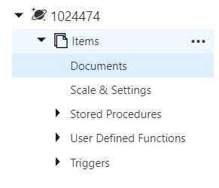
Figure 1.

The content model can be either defined by user defined content or system-defined schema. The content model of the item resource is depended on atom-record-sequence (ARS) which is that atoms compose of a small set of primitive types e.g. string, bool, number etc. records are structs and sequences are arrays composing of atoms, records, or sequences. Both container and item resources are further utilized depending on resource types for a definite type of API interface as figure 2 below.

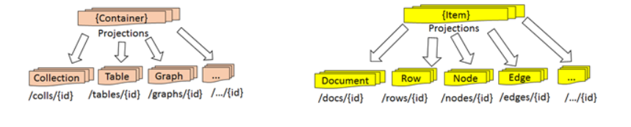
Figure 2.

For instance, in our case, while utilizing document-oriented APIs, container and item resources are taken advantage of collection (container) and document(item) resources. Table 1 below shows the usage of containers and items based on the data model of the specific API.

Table 1.
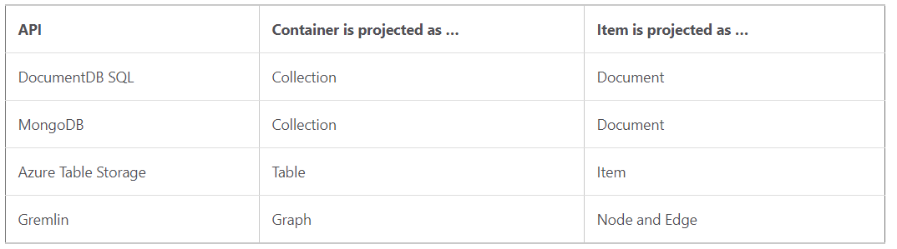

4. API

As you can see the table above, a variety of APIs are supported in Azure Cosmos Database. Each API can be used for their own purpose. In our paper, we utilize the SQL API which is based on document database. The SQL API allows to control JSON data through well-defined database resources. What is the benefit of using SQL API is all data resources can be accessed by their logical URL, thereby clients can easily access the application such as Java, Python, .Net and etc. The account in Azure Cosmos Database is a unique namespace that allows you to access to Azure Cosmos DB. Before you create Azure account, you need to have a subscription in Azure Cosmos DB. All resources are modeled and saved as JSON documents. Following figure 3 shows the relationships between the Azure Cosmos DB resources:

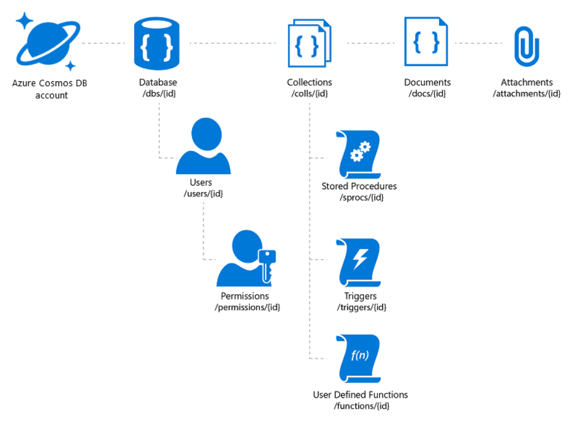
Figure 3.

Once you create the database and collection, each document has its own id and is stored depended on properties as following figure 4 below.

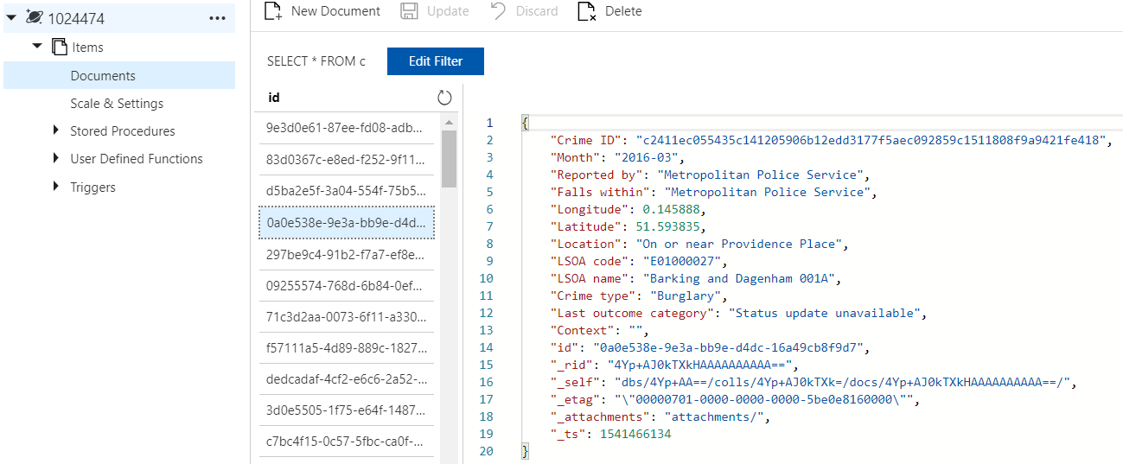
Figure 4.

1024474 and Items represent database name and collection name respectively on above. Once you put up the documents, you can make any query in Azure Cosmos DB using certain properties. In our case, there are several properties such as Crime ID, Month, Reported by, Crime type, id and so on. Following figure 5 displays one of the examples for the SQL query in Azure Cosmos DB.

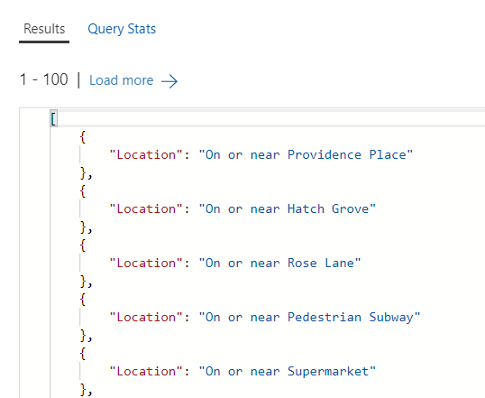
Figure 5.

Above image represents the locations crimes appeared based on the crime type using following query:
SELECT c["Location"] FROM c
where c["Crime type"] = "Burglary"
Not only you can utilize query simply but also you can look into the query status as following figure 6.

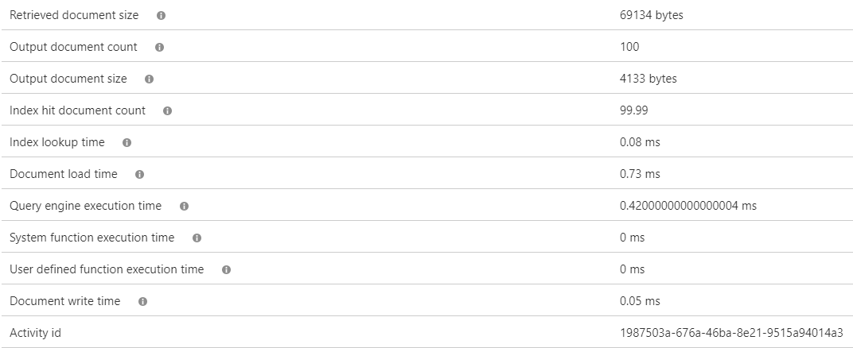
Figure 6.

By seeing above figure, you can evaluate how fast Azure Cosmos DB processes resources in documents under collection.

5. implementation

Azure Cosmos DB can be connected to different types of applications such as Java, Python, .Net and etc. In our paper, we implemented a web application using .Net as a MVC framework based on C# on Visual Studio 2017. First you need to do is to set up appSettings as following figure 7.

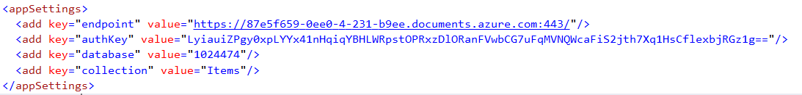
Figure 7.

As referred before in API section, all data can be accessed by logical URL and with database and collection id. All resources are retrieved from the Azure Cosmos DB as figure 8 below.

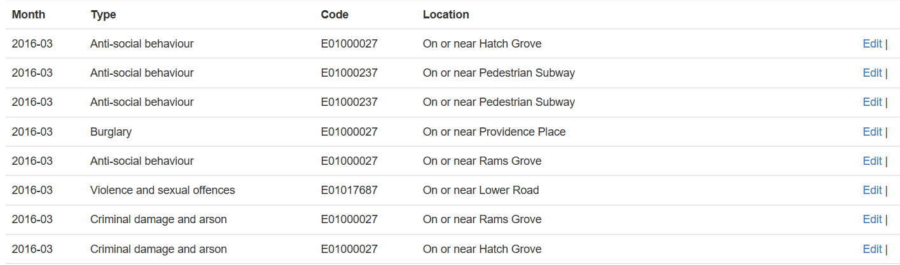
Figure 8.

To analyze how each property is related, we extract specific properties as shown above. In our application, in order to access to Azure Cosmos DB, we use a repository class which is directly accessed into Azure Cosmos DB using already-defined library in C#. That repository class is called by controller class when we retrieve resources in the browser. For the visualization in the web browser, we use the concept of view which is supported in MVC model.

6. Conclusion

Azure Cosmos Database which is globally distributed-database has been utilized a lot recently because of their convenient and efficient characteristics such as scalability and high availability. Even though we utilize one database model and API in our research, it shows a lot of benefits such as easiness of using the database and query at the same time, and also of access with the application as well. Azure Cosmos DB shows high speed of processing data resources based on a lot of globally-distributed servers. Considering all features in Azure Cosmos DB, Azure Cosmos DB is reliable and consistent database.

7. References

[1] A. A. Imam, S. Basri, R. Ahmad, N. Aziz and M. T. Gonzålez-Aparicio, "New cardinality notations and styles for modeling NoSQL document-store databases," TENCON 2017 - 2017 IEEE Region 10 Conference, Penang, 2017, pp. 2765-2770.
[2]https://docs.microsoft.com/en-us/azure/cosmos-db/distribute-data-globally
[3]https://azure.microsoft.com/en-us/blog/a-technical-overview-of-azure-cosmos-db/
[4]https://stackify.com/what-is-azure-cosmos-db/

